- Setup a Jenkins CICD pipeline using Declarative pipeline using feature-1.1 branch. https://github.com/betawins/sabear_simplecutomerapp/tree/feature-1.1
stages:
- Git Clone
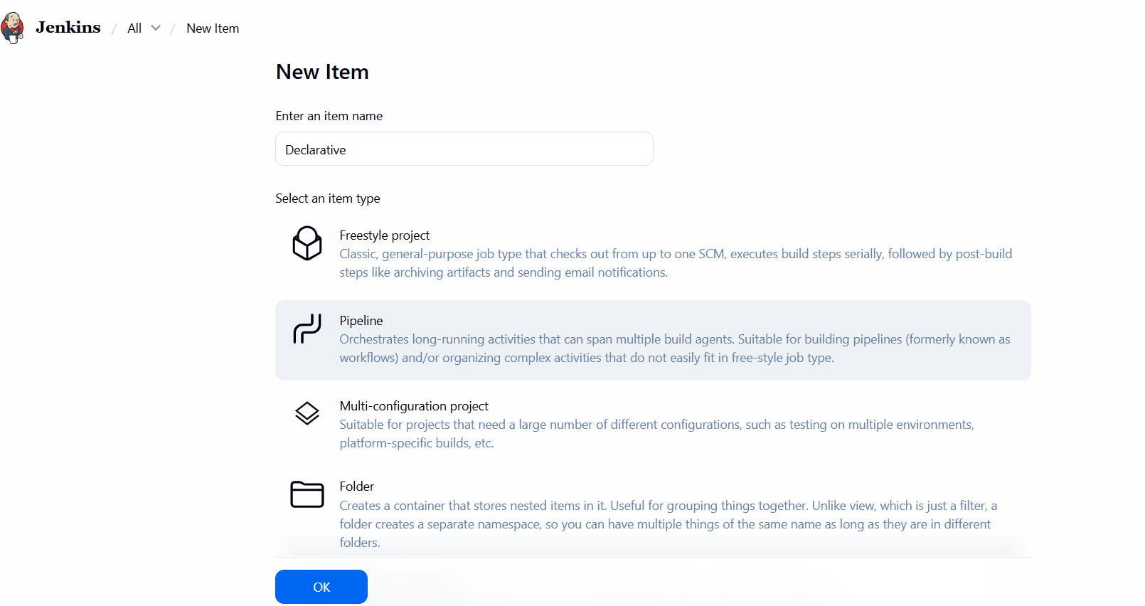
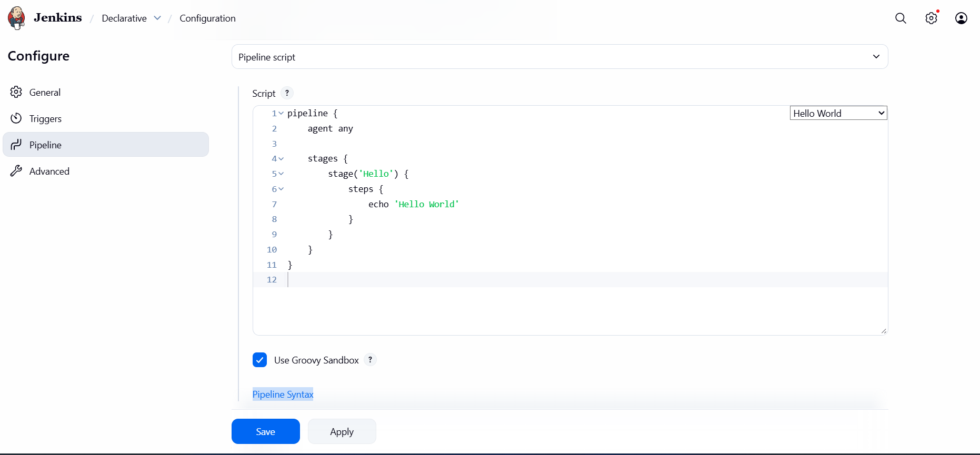
Click on pipeline syntax and select git.
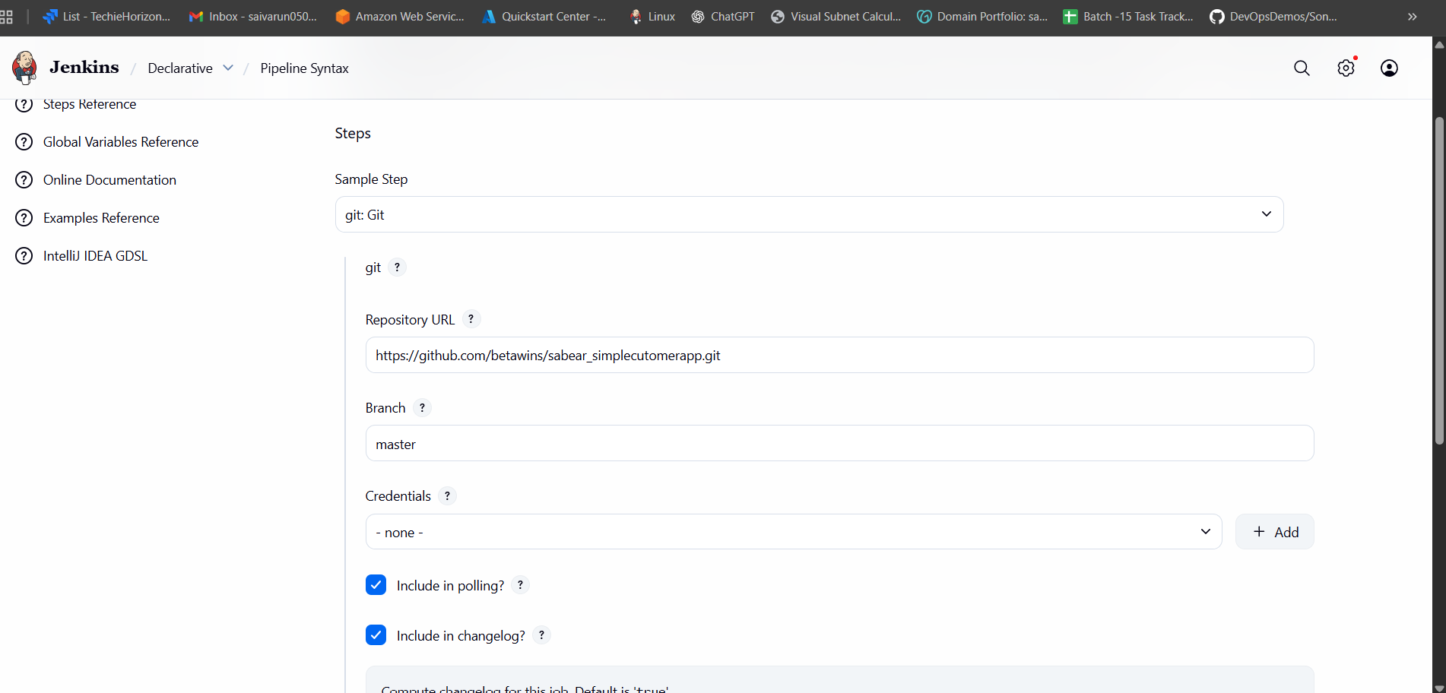
Click on generate pipeline script, It will generate a link copy it.
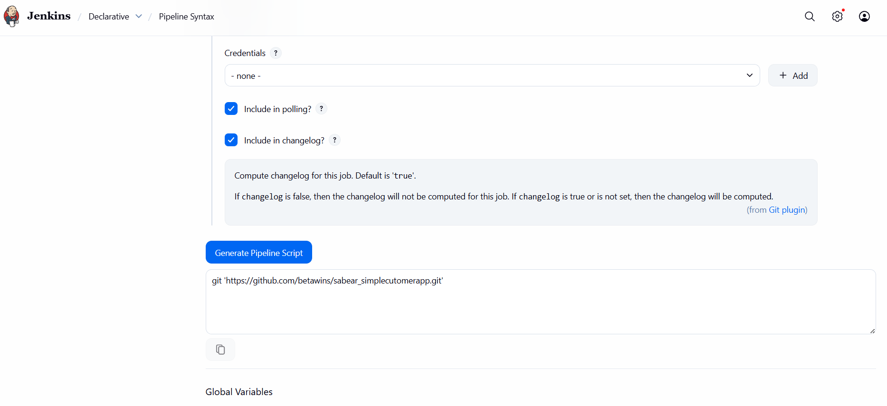
git 'https://github.com/betawins/sabear_simplecutomerapp.git'
Add it in pre defined script and save.
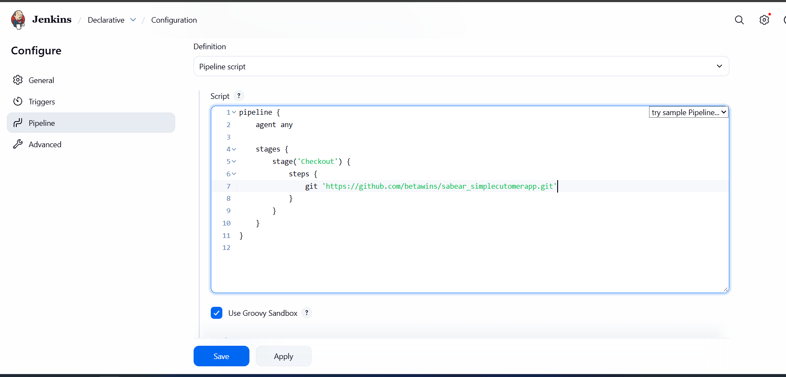
Now, Check it is cloning or not by build now.
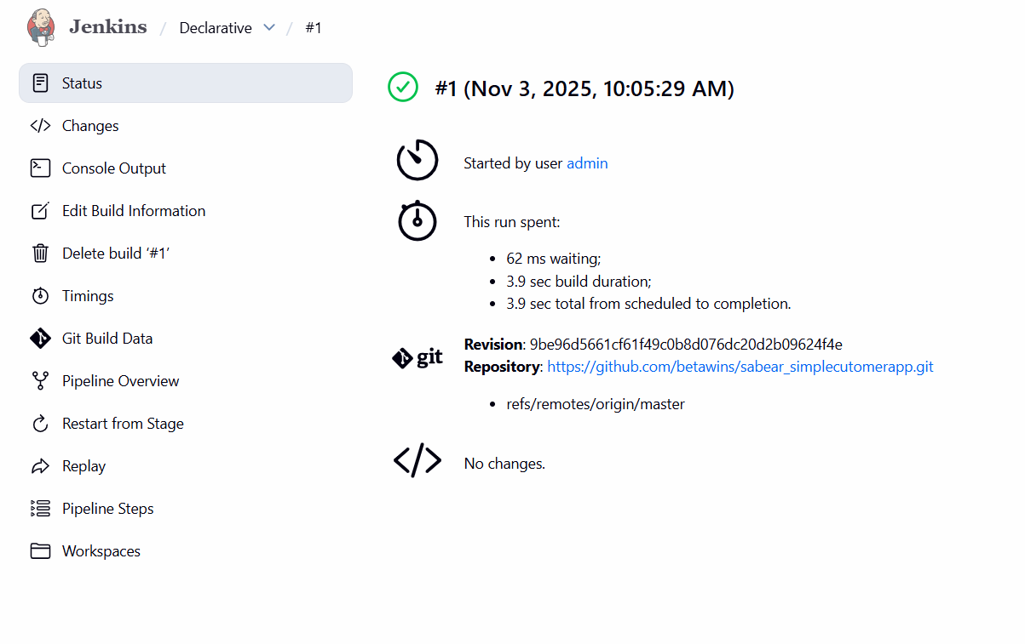
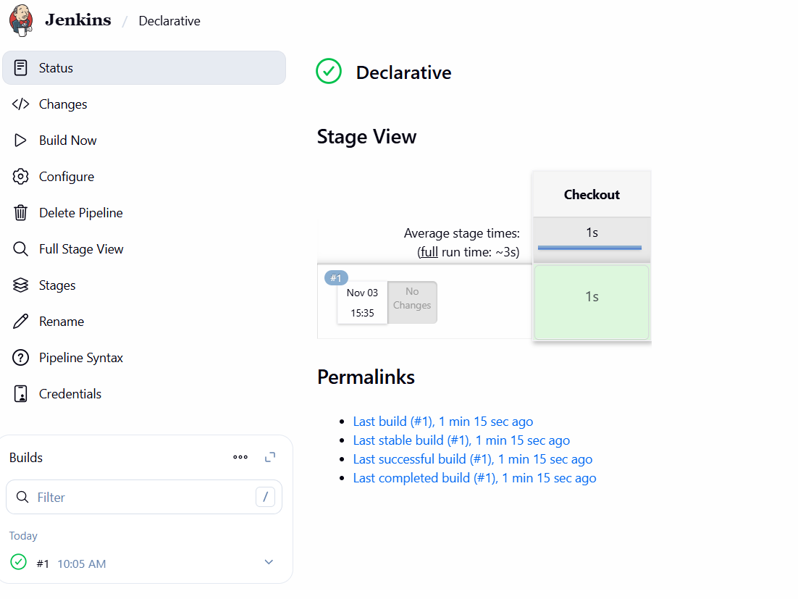
- Maven Compilation

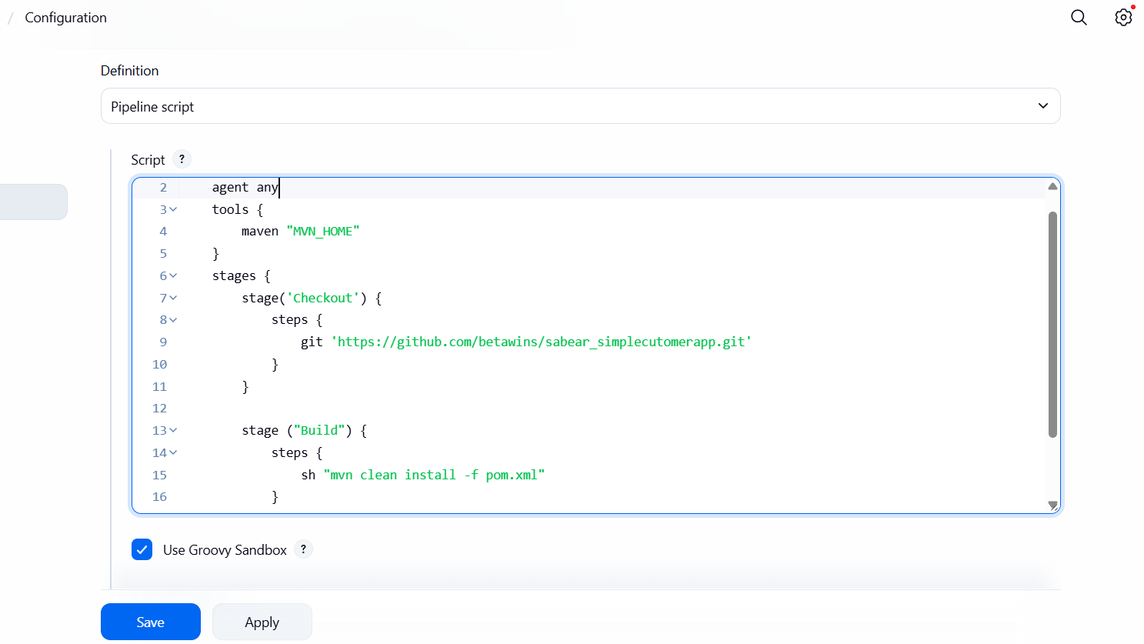
Change the script according to your maven name and where your pom.xml file is located in my case Its MVN_HOME and location of pom.xml is on main path.
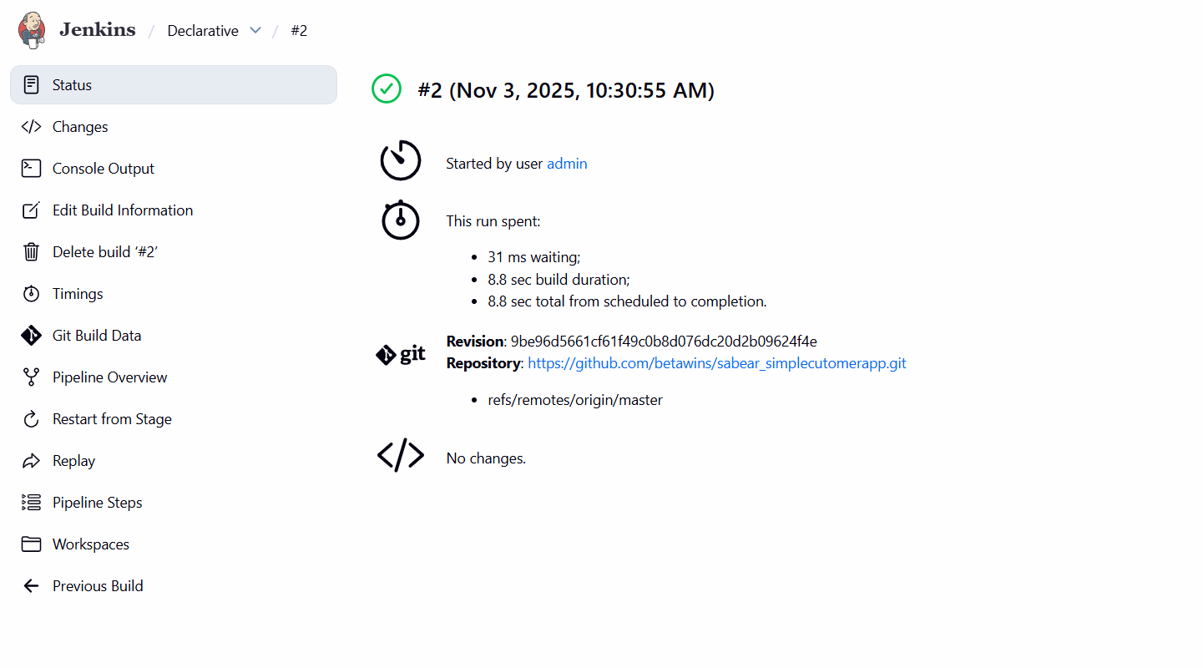
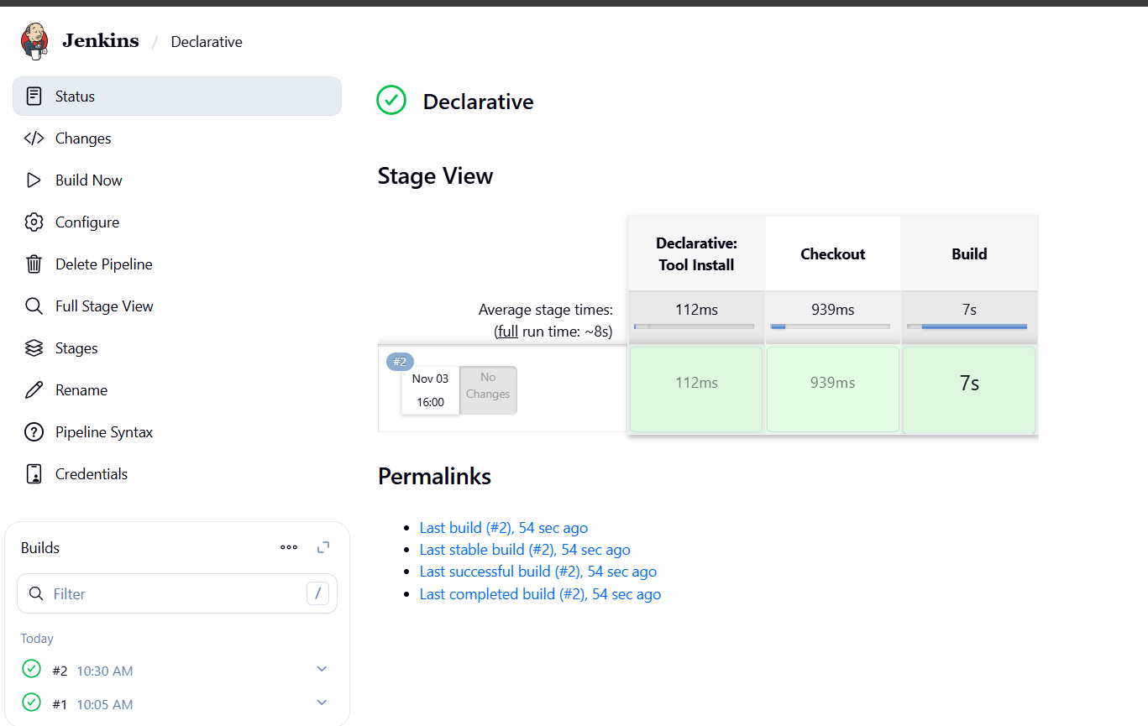

- Sonar integration

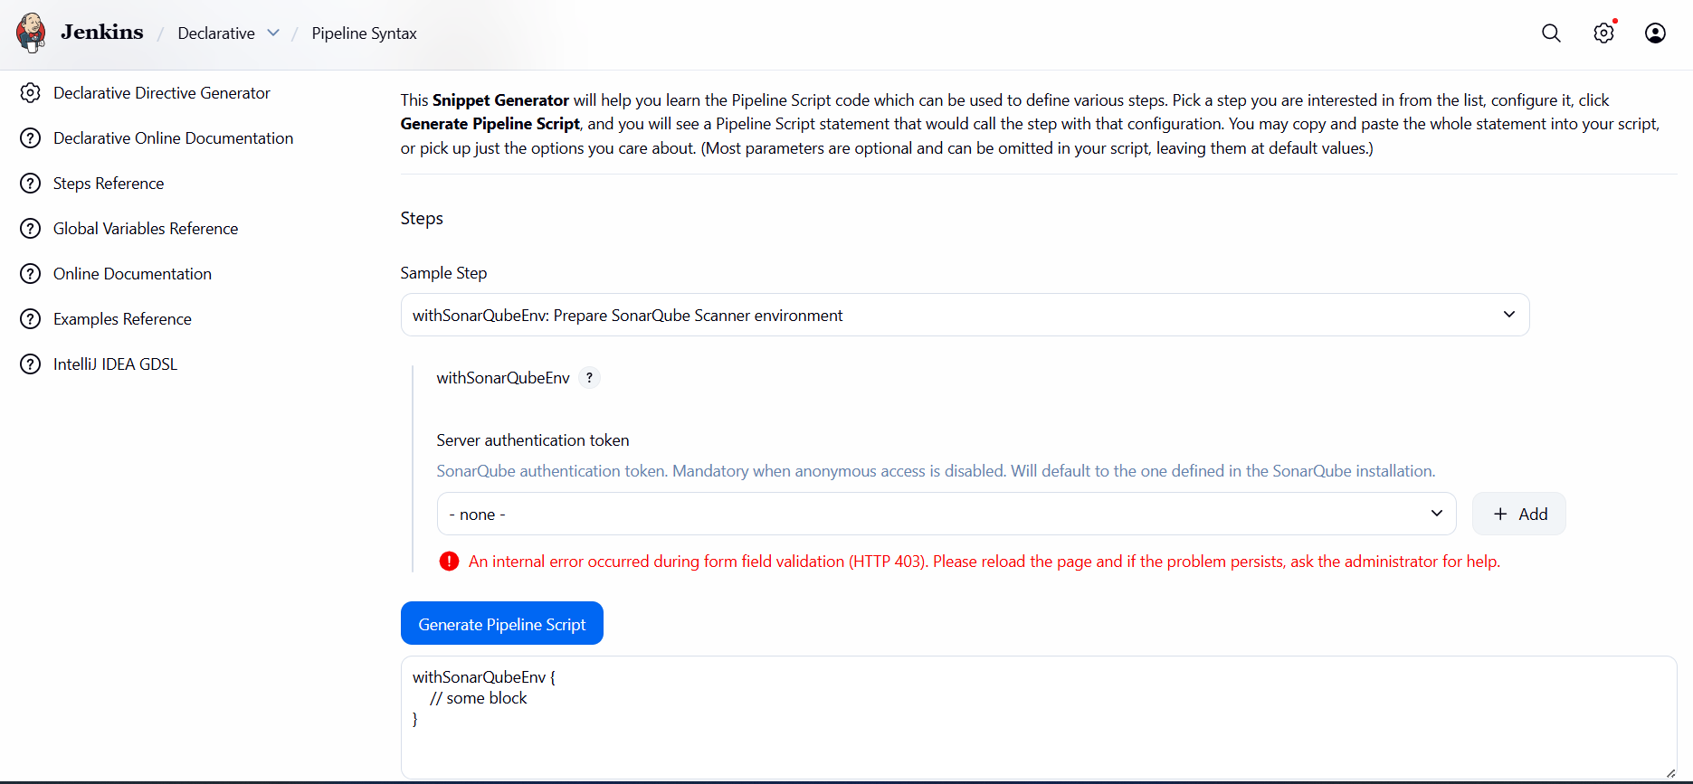
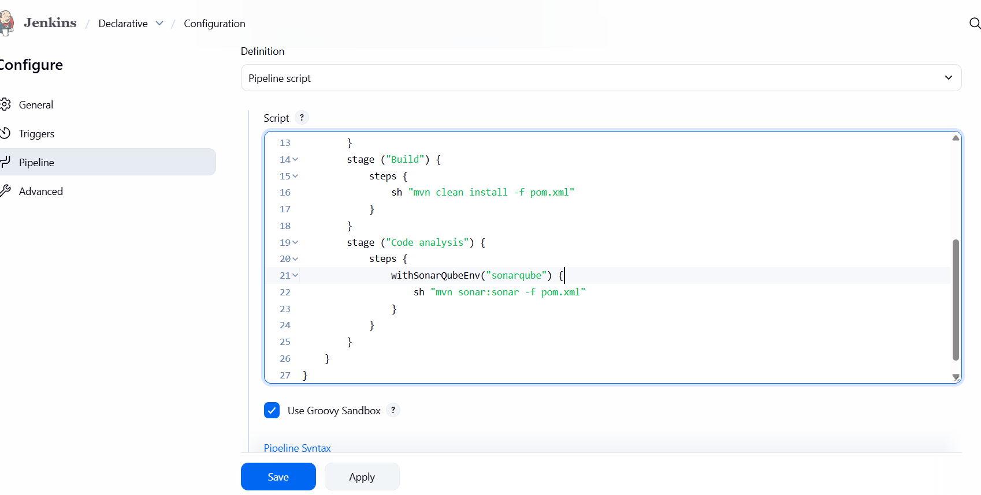

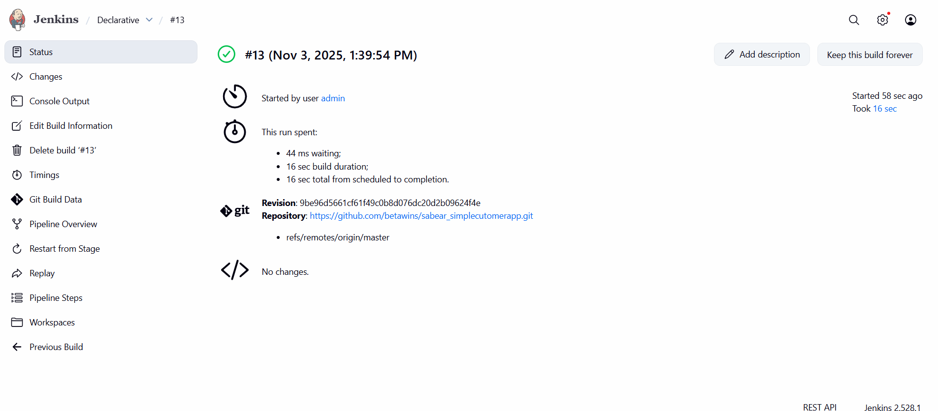

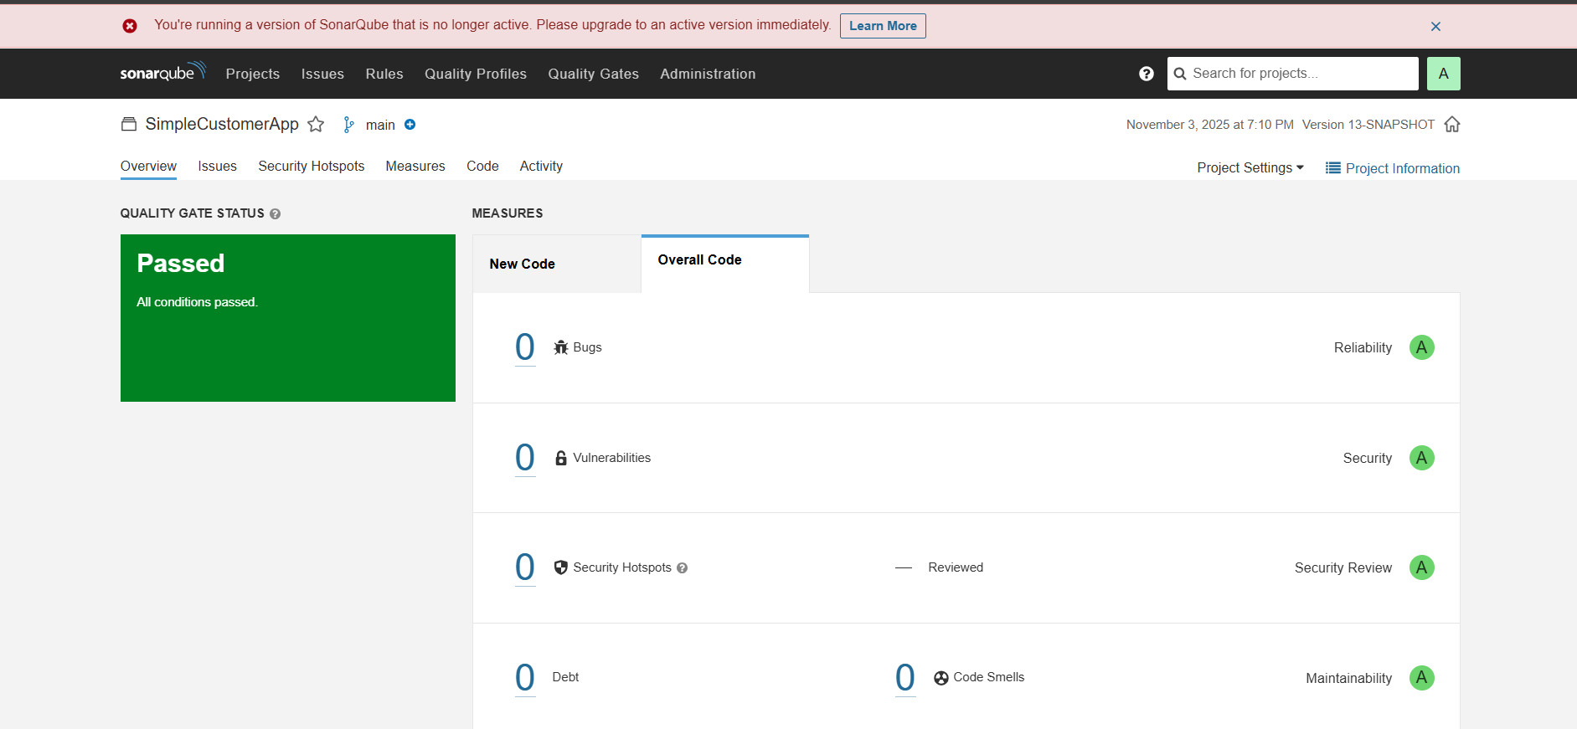

- Nexus
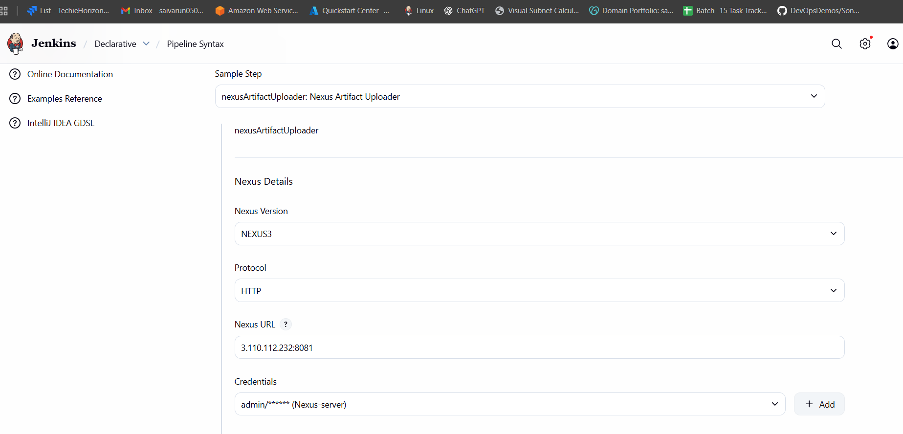

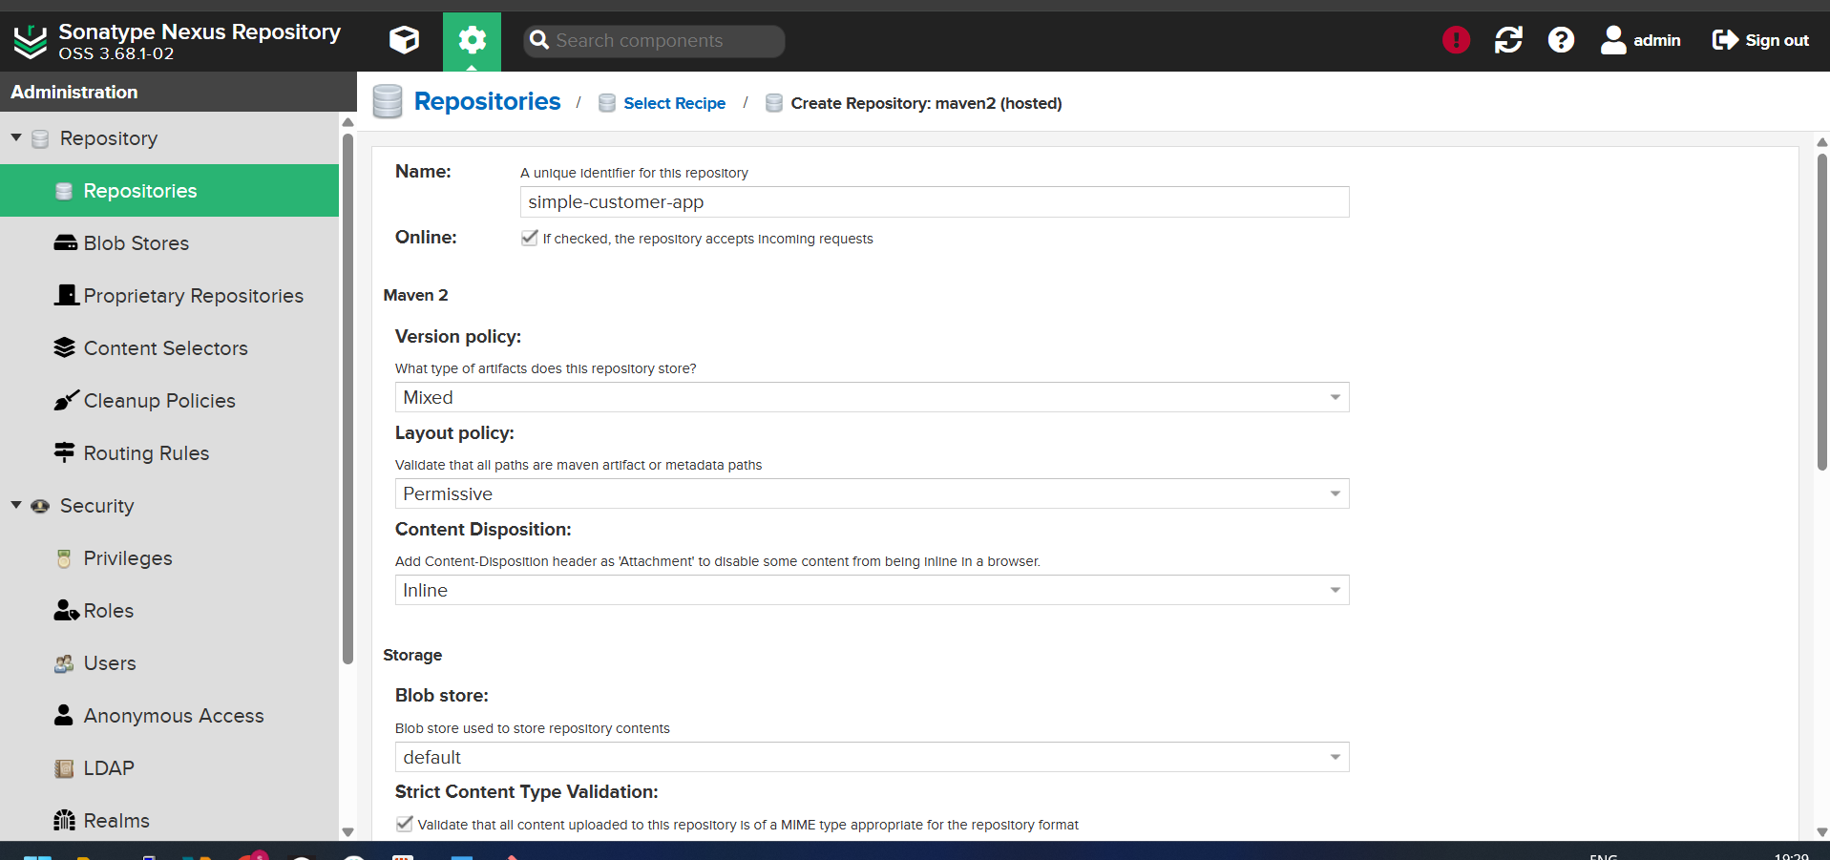
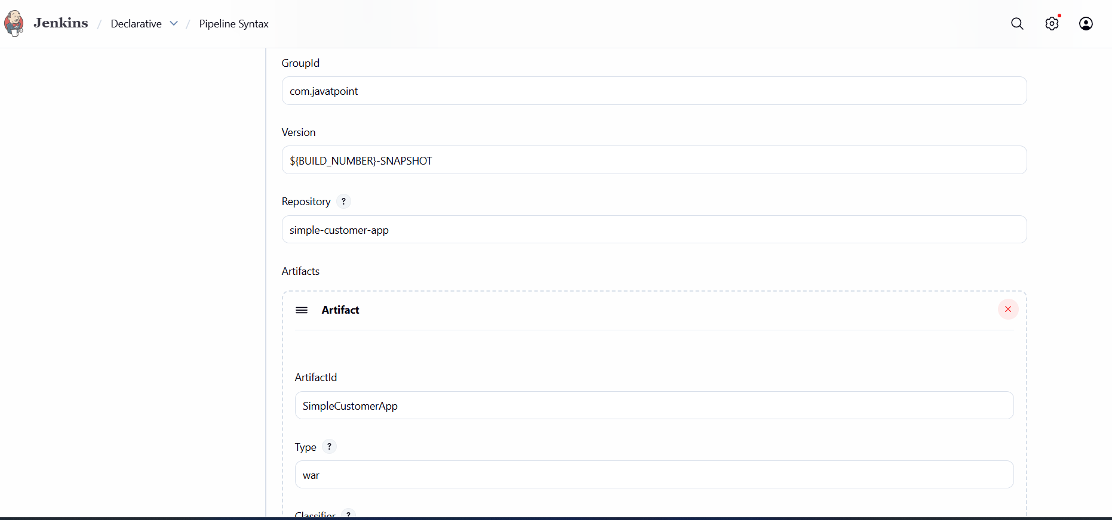
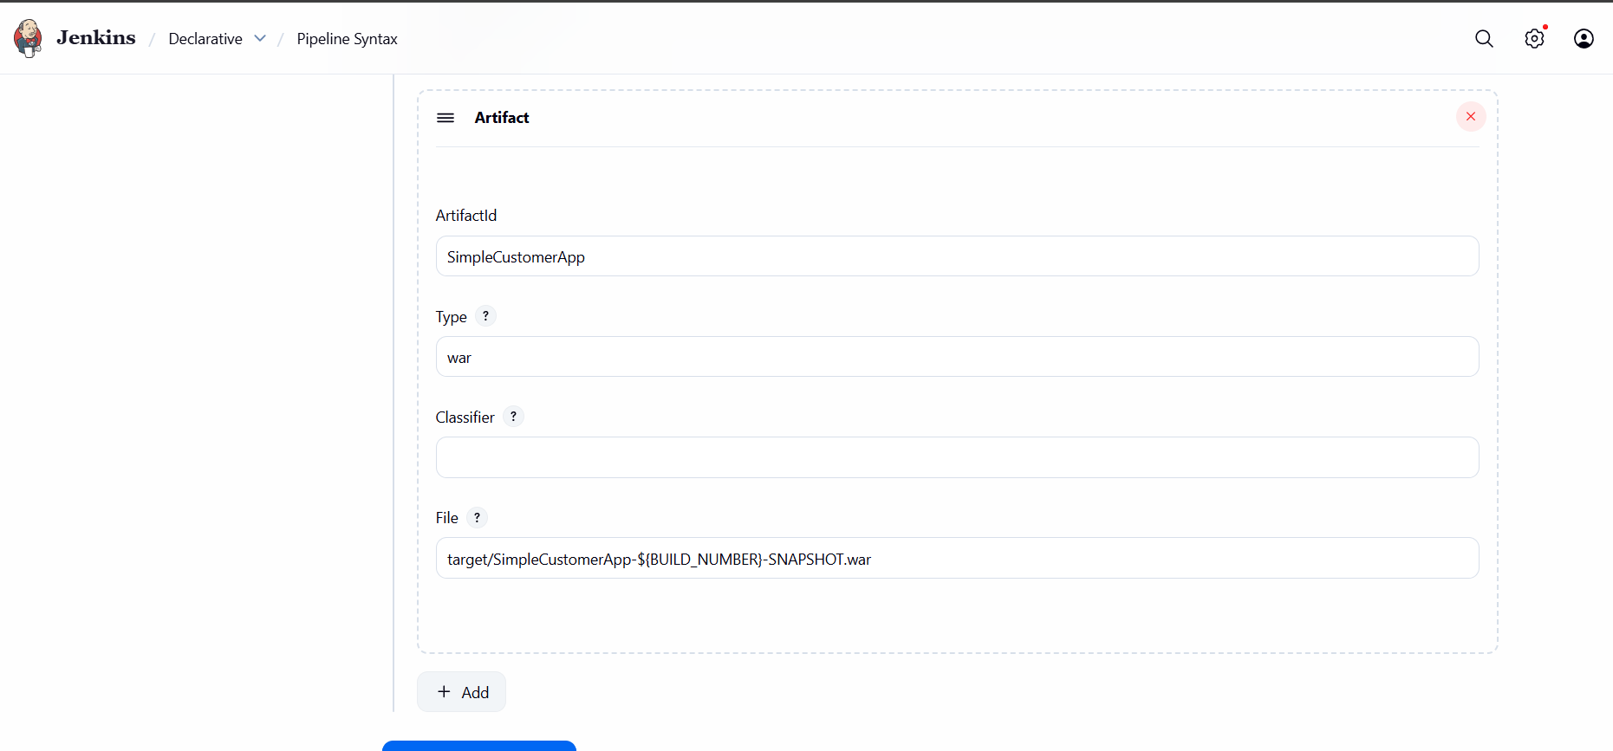
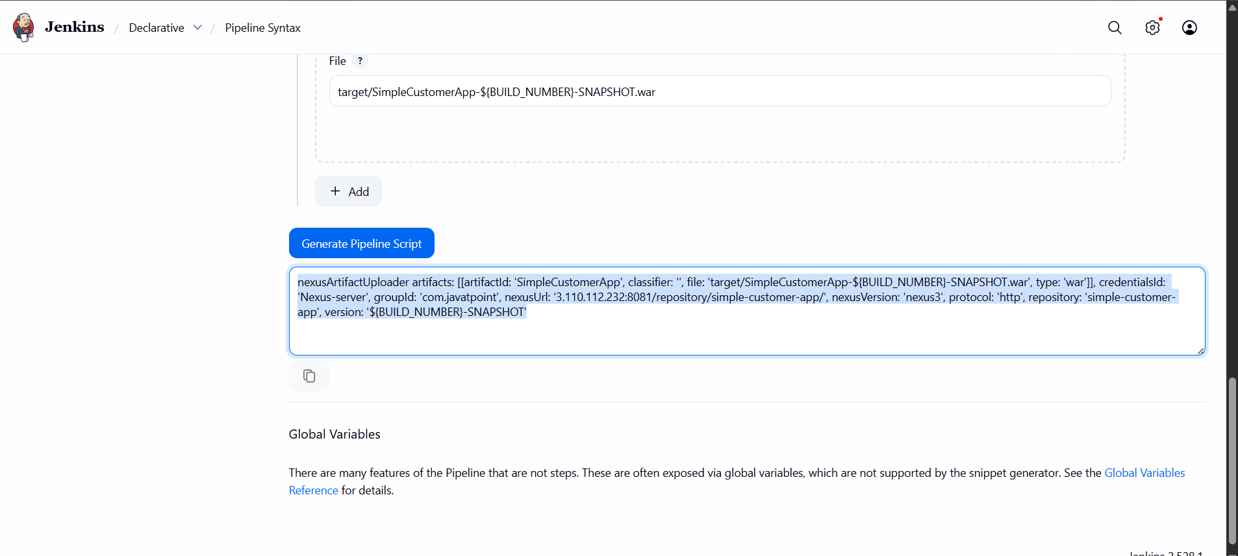

nexusArtifactUploader artifacts: [[artifactId: 'SimpleCustomerApp', classifier: '', file: 'target/SimpleCustomerApp-${BUILD_NUMBER}-SNAPSHOT.war', type: 'war']], credentialsId: 'Nexus-server', groupId: 'com.javatpoint', nexusUrl: '3.110.112.232:8081', nexusVersion: 'nexus3', protocol: 'http', repository: 'simple-customer-app', version: '${BUILD_NUMBER}-SNAPSHOT'

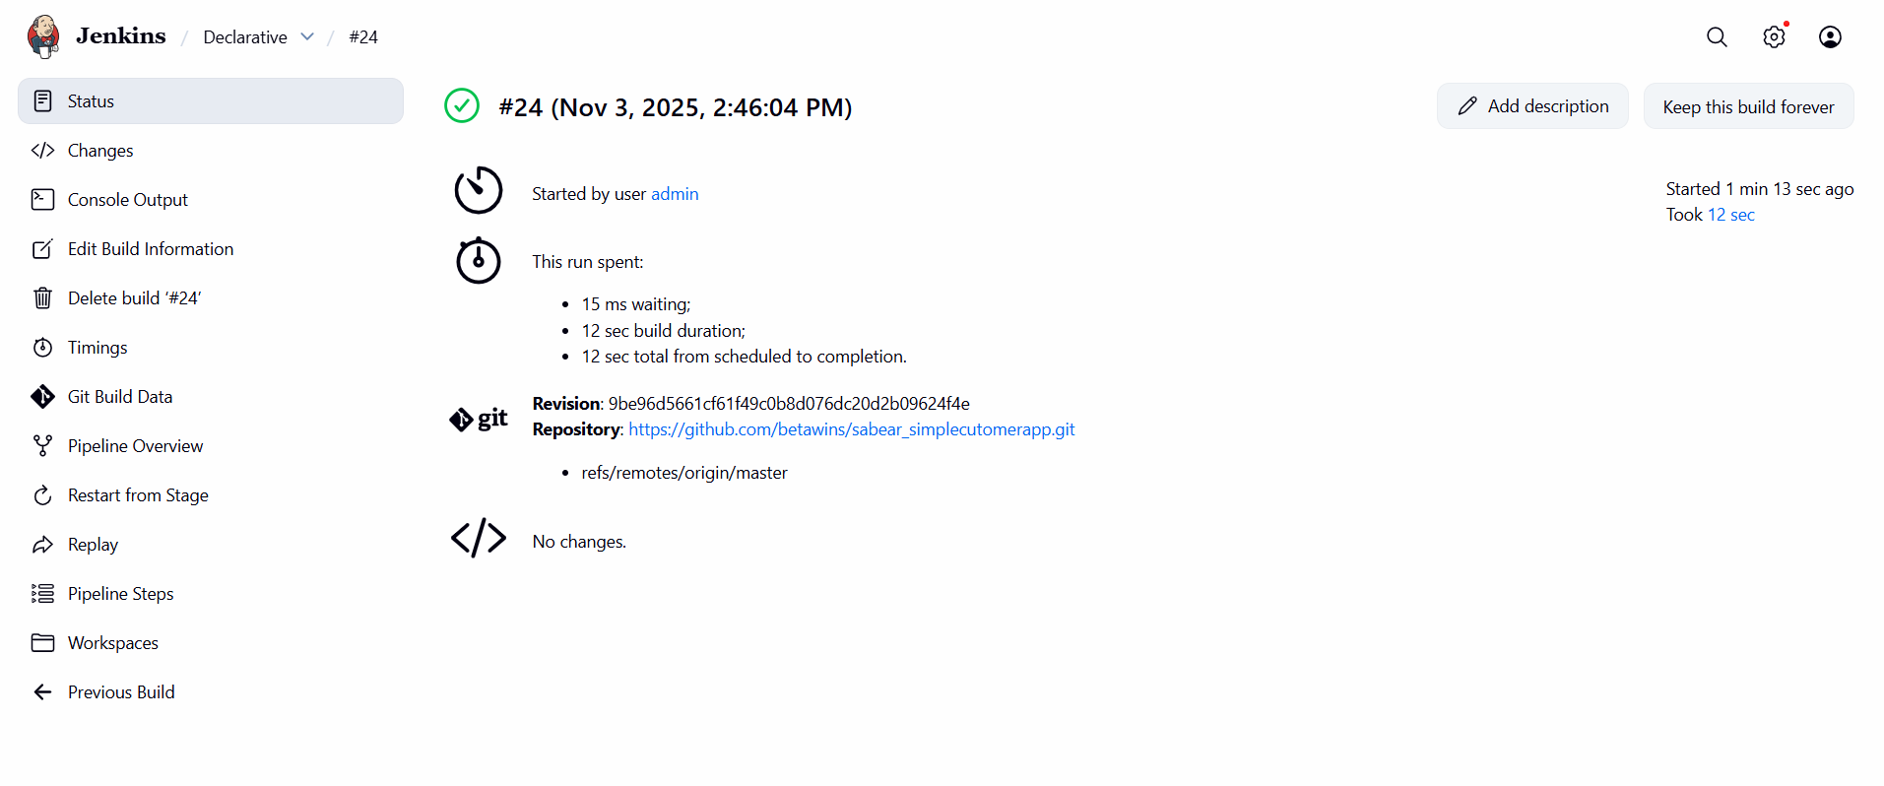

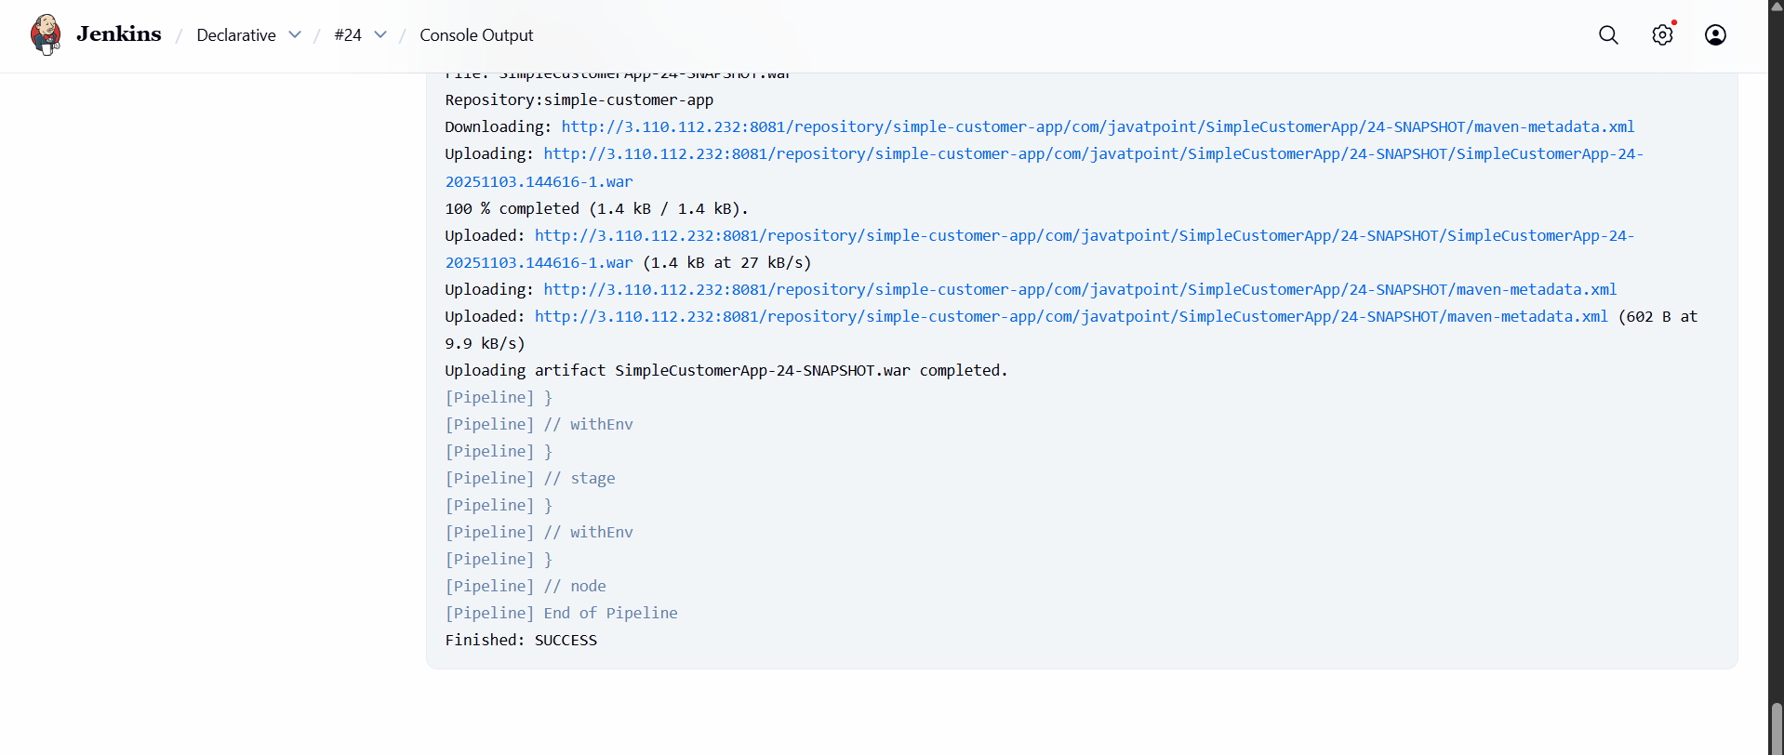

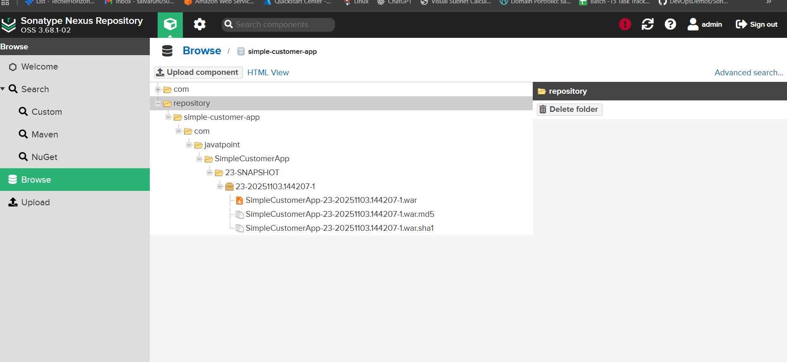

- Deploy in tomcat
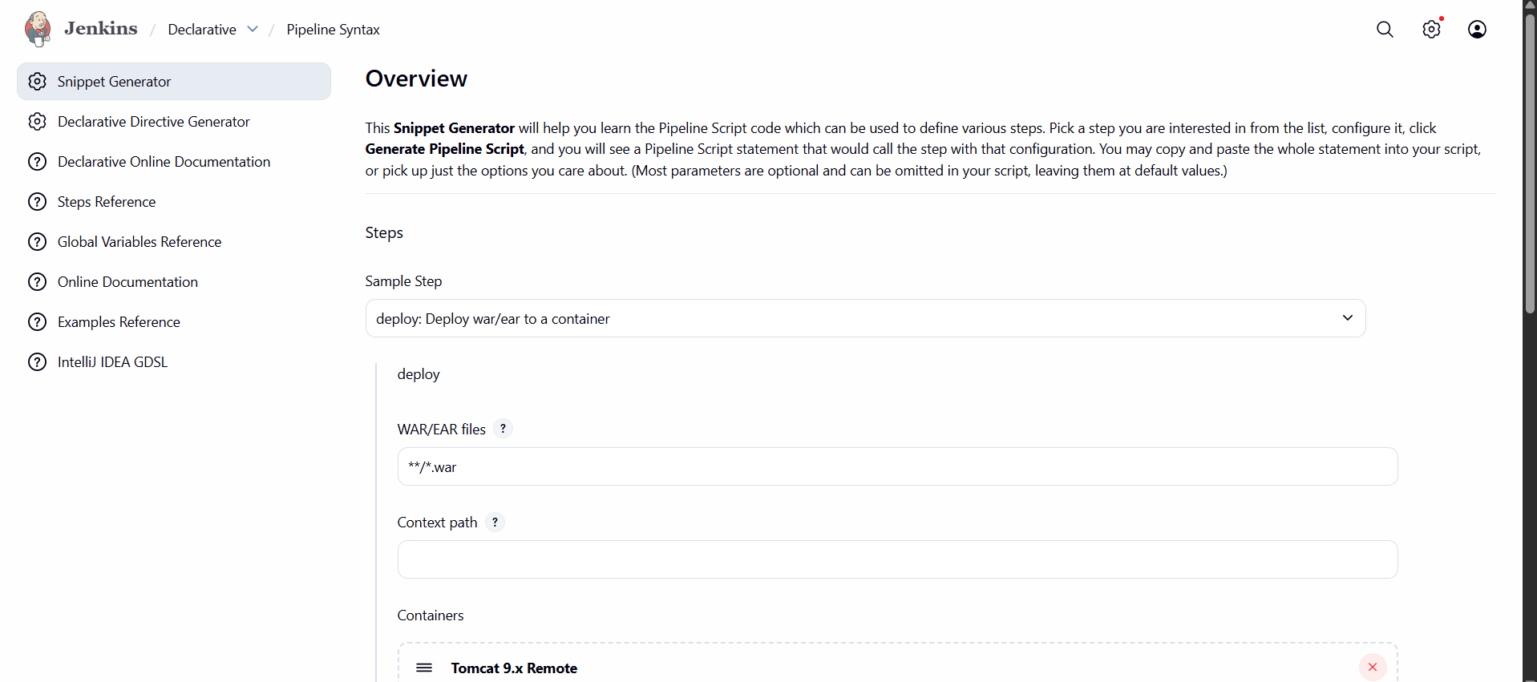
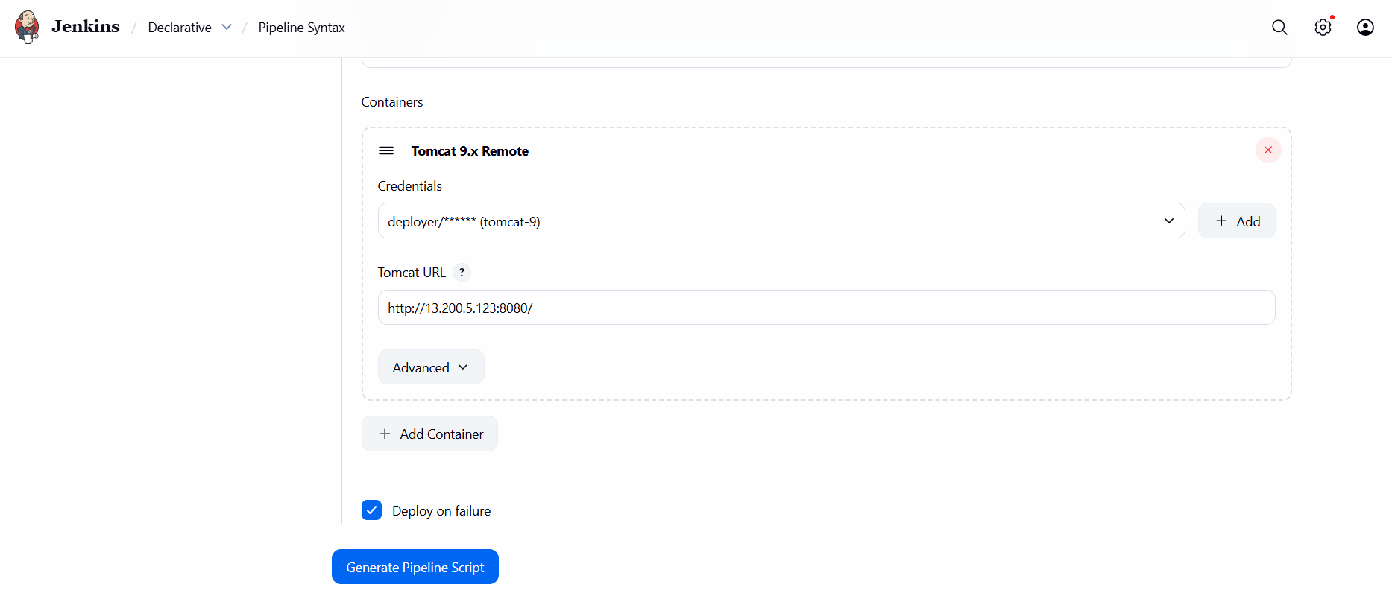
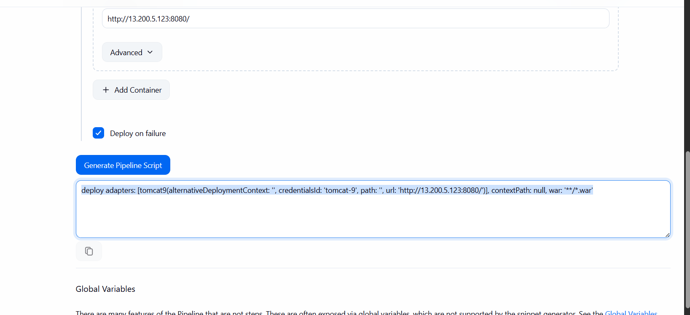

deploy adapters: [tomcat9(alternativeDeploymentContext: '', credentialsId: 'tomcat-9', path: '', url: 'http://13.200.5.123:8080/')], contextPath: null, war: '**/*.war'

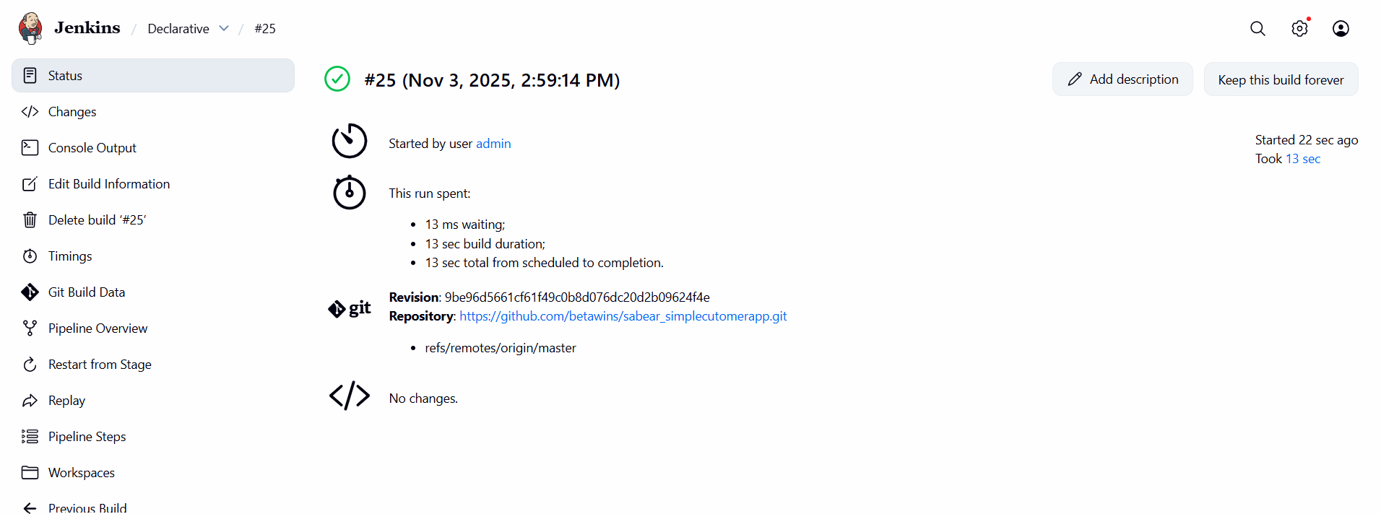

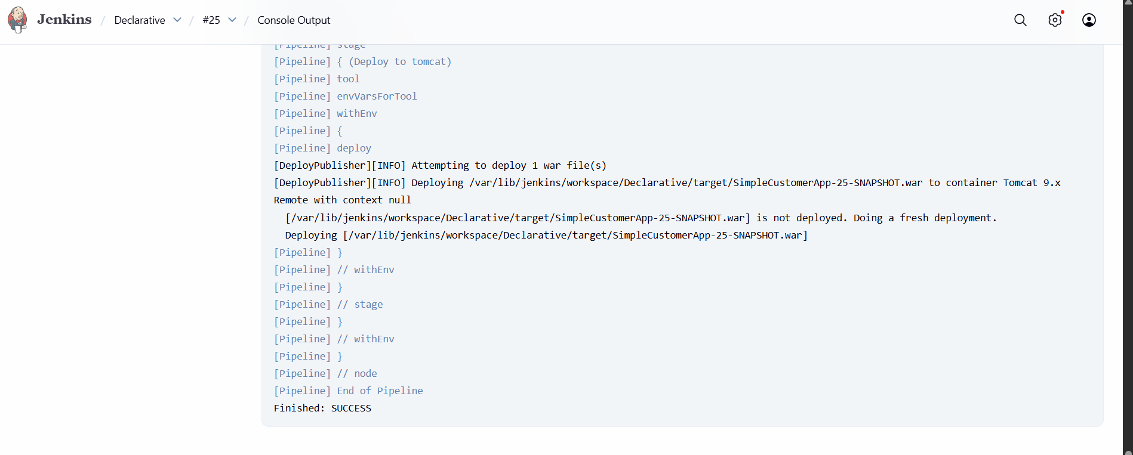

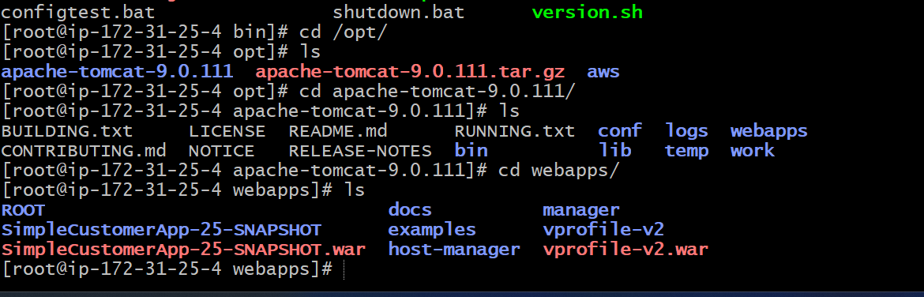
- Slack integration

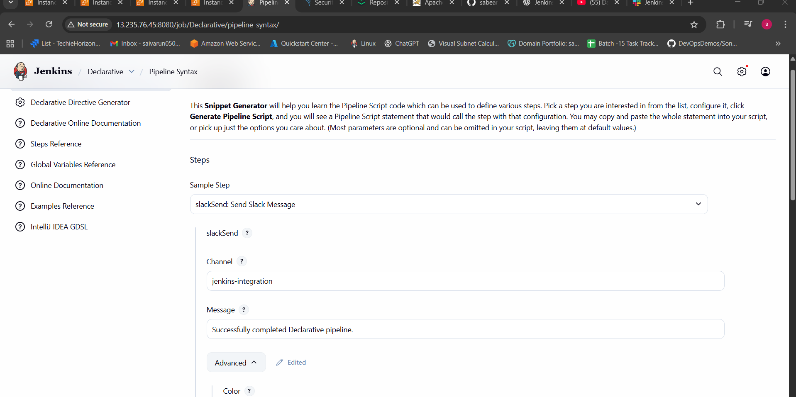

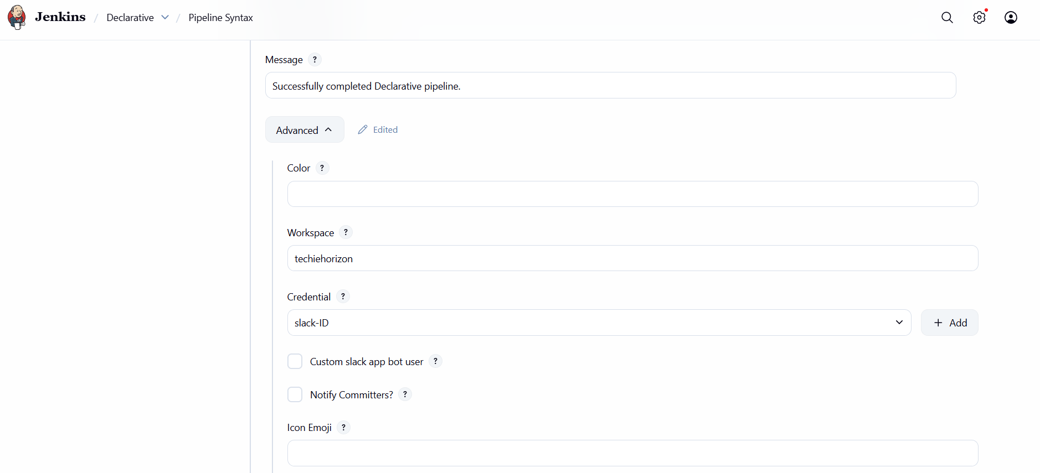

Add your username [saivarun-15] in slack-id

slackSend channel: 'jenkins-integration', message: 'Successfully completed Declarative pipeline.', teamDomain: 'techiehorizon', tokenCredentialId: 'saivarun-15'

